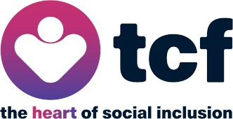

Subject: Sad News – Passing of Our Chair, David Cottam
Dear member,
It is with deep sadness that we inform you of the passing of our Chair, David Cottam, in 2024. David’s leadership and dedication were invaluable to our organisation, and his vision has left a lasting impact.
As we continue to build upon the solid foundation David and the Board have established, we will continue to hold David and his family in our thoughts.
David was a man of principle and of humour. Through Covid19, lockdown and a difficult commissioning landscape, David remained positive, supportive, and focussed on
enabling communities and individuals from a compassionate standpoint. He was well respected by staff and in turn respected and was inspired by their work.
Thank you for standing with us as we honour David’s legacy and continue our important work.
With sympathy and gratitude,

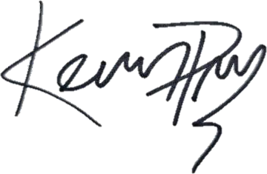

Kevin Peltonen-Messenger CEO
TCF

1 | P a g e

